Abstract:

The goal of this project is to provide a realistic experience in the conceptual design, logical design, implementation, operation, and maintenance of a relational database and associated applications.

Problem Description:

The application is an automobile company, such as General Motors, Ford, Toyota, or Volkswagen (or maybe a company from yesteryear like Studebaker, Hudson, Nash, or Packard).

In our hypothetical company, it has been decided to redesign a major part of the database that

underlies company operations. Unfortunately, the manager assigned to solicit database design

proposals is not very computer literate and is unable to provide a very detailed specification at

the technical level. Fortunately, you are able to do that.

E-R Diagram:

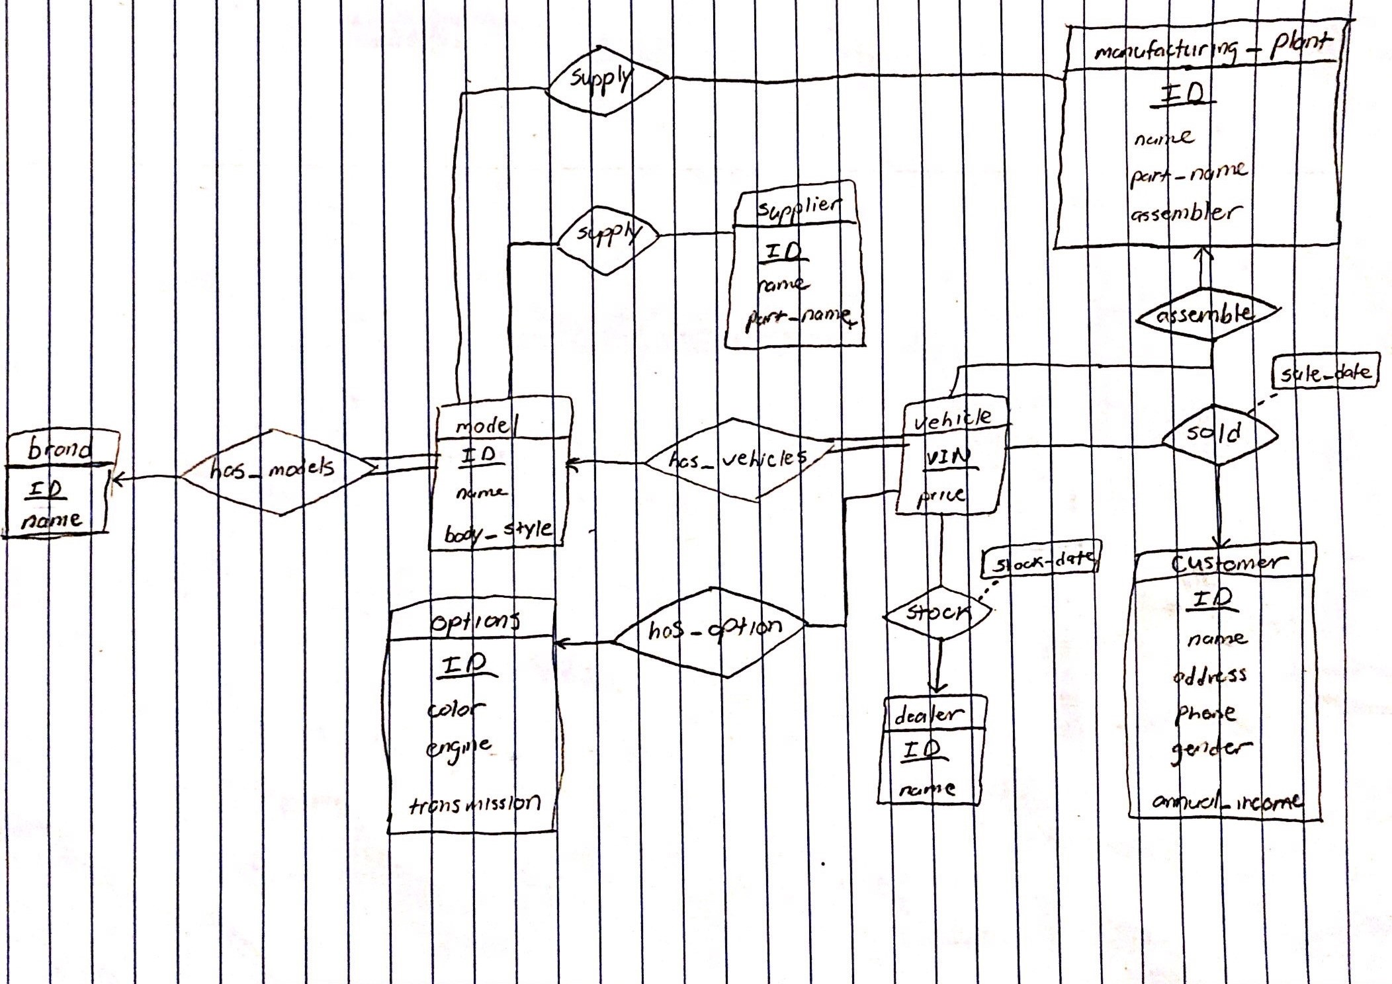

Relational Schema:

*brand(brand_id, brand_name)*

*model(model_id, brand_id, model_name, body_style)*

*vehicle(VIN, model_id, option_id, plant_id, dealer_id, price, stock_date)*

*option(option_id, color, engine, transmission)*

*customer(customer_id, customer_name, address, phone_no, gender, annual_income)*

*dealer(dealer_id, dealer_name)*

*supplier(supplier_id, supplier_name, part_name)*

*manufacturing_plant(plant_id, plant_name, part_name, assembler)*

*supply(supplier_id, model_id,*

**foreign key** *supplier_id* **references** *supplier,*

**foreign key** *model_id* **references** *model)*

*sold(VIN, customer_id, sale_date,*

**foreign key** *VIN* **references** *vehicle*,

**foreign key** *customer_id* **references** *customer)*

*stock(VIN, dealer_id, stock_date,*

**foreign key** *VIN* **references** *vehicle,*

**foreign key** *dealer_id* **references** *dealer)*

*assemble(VIN, plant_id,*

**foreign key** *VIN* **references** *vehicle,*

**foreign key** *plant_id* **references** *manufacturing_plant)*

*has_models(brand_name, model_id,*

**foreign key** *brand_name* **references** *brand,*

**foreign key** *model_id* **references** *model)*

*has_vehicles(model_id, VIN,*

**foreign key** *VIN* **references** *vehicle,*

**foreign key** *model_id* **references** *model)*

*has_option(VIN, model_id, option_id,*

**foreign key** *VIN* **references** *vehicle,*

**foreign key** *model_id* **references** *model,*

**foreign key** *option_id* **references** *option)*

Implementation Details:

* MySQL database created using the SQL language in MySQL Workbench 8.0 CE
* MySQL Command-Line Client used as the interface to implement any queries, including the sample queries listed below
  + For the administrator interface, commands can be entered in the command line after connecting the database to the terminal.
  + The marketing department can also enter any OLAP query statements through the command line, just like the administrator.

Running Results and Analysis:

Query images and their code (Images also provided in “Results” folder under “Query Screenshots” if the images here are too small to read):

* Show sales trends for various brands over the past 3 years, by year, month, week. Then break these data out by gender of the buyer and then by income range.
  + By year:

select brand_name, count(brand_id) as unit_sales, year(sale_date) as year

from vehicle natural join sold natural join model natural join brand

where sale_date between '2021-01-01' and '2023-12-31'

group by year, brand_name

order by brand_name, year desc;

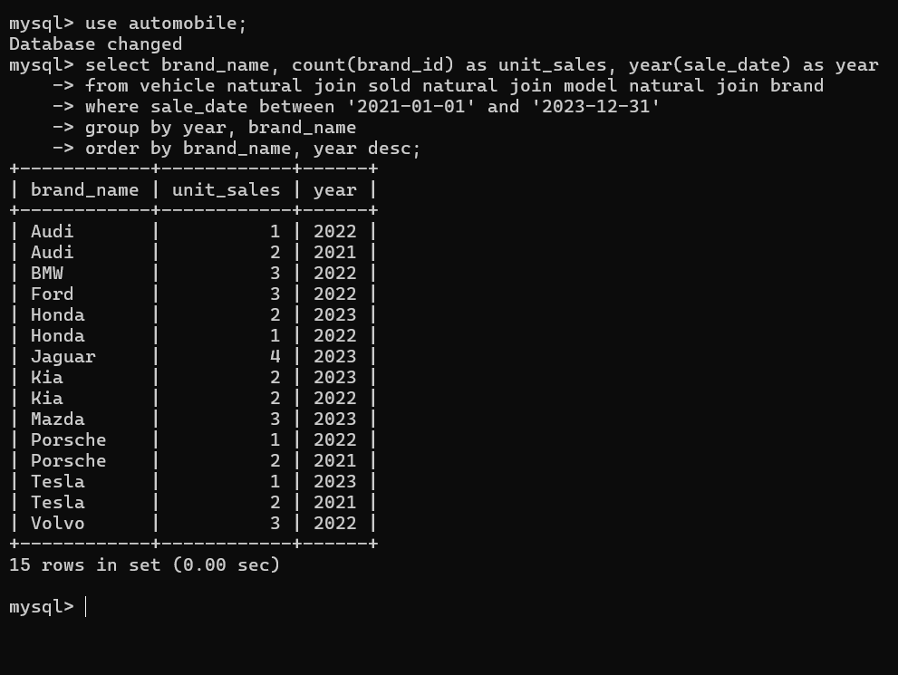

* + By month:

select brand_name, count(brand_id) as unit_sales, year(sale_date) as year, month(sale_date) as month

from vehicle natural join sold natural join model natural join brand

where sale_date between '2021-01-01' and '2023-12-31'

group by year, brand_name, month

order by brand_name, year desc, month desc;

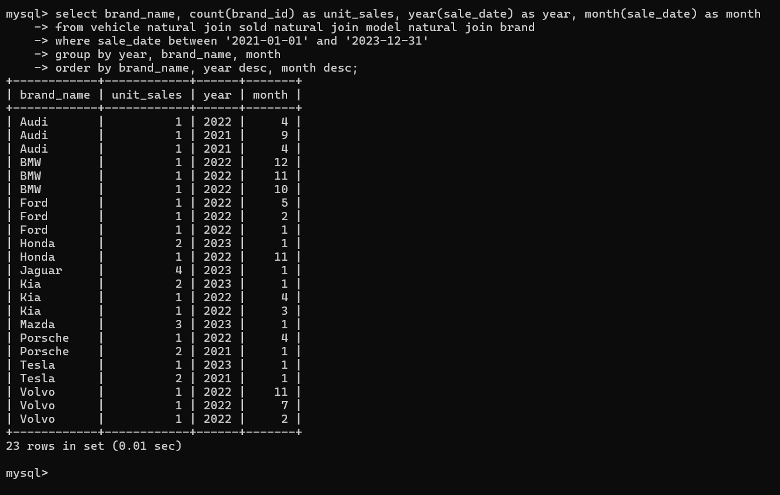

* + By week:

select brand_name, count(brand_id) as unit_sales, year(sale_date) as year, month(sale_date) as month, week(sale_date) as week

from vehicle natural join sold natural join model natural join brand

where sale_date between '2021-01-01' and '2023-12-31'

group by year, brand_name, month, week

order by brand_name, year desc, month;

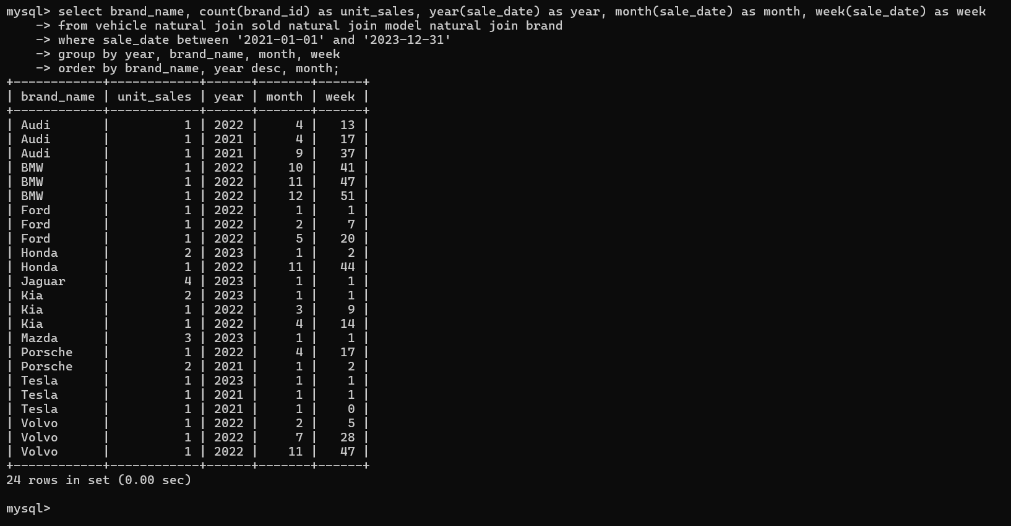

* + By gender:
    - Both genders:

select customer_id, gender, annual_income, brand_id, brand_name, count(brand_id) as unit_sales, year(sale_date) as year, month(sale_date) as month, week(sale_date) as week

from vehicle natural join sold natural join model natural join brand natural join customer

where sale_date between '2021-01-01' and '2023-12-31'

group by year, brand_name, month, week, brand_id, customer_id, gender, annual_income

order by brand_name, year desc, month;

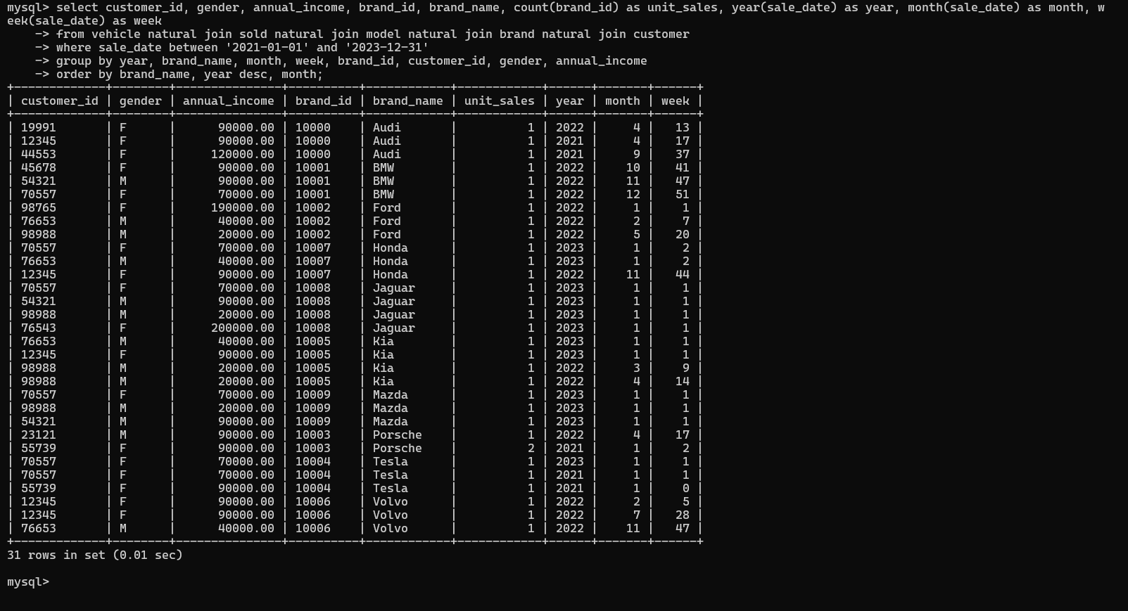

* + - Male:

select customer_id, gender, annual_income, brand_id, brand_name, count(brand_id) as

unit_sales, year(sale_date) as year, month(sale_date) as month, week(sale_date) as week

from vehicle natural join sold natural join model natural join brand natural join customer

where sale_date between '2021-01-01' and '2023-12-31' and gender = 'M'

group by year, brand_name, month, week, brand_id, customer_id, gender, annual_income

order by brand_name, year, month desc;

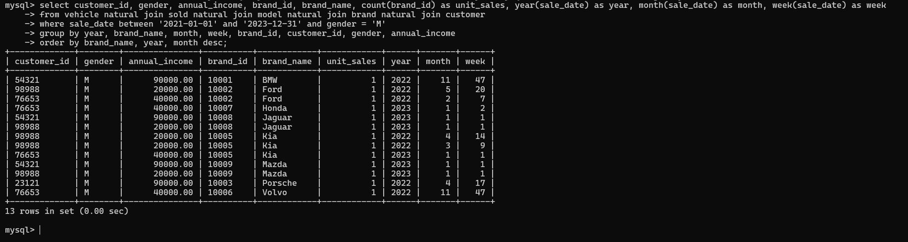

* + - Female:

select customer_id, gender, annual_income, brand_id, brand_name, count(brand_id) as

unit_sales, year(sale_date) as year, month(sale_date) as month, week(sale_date) as week

from vehicle natural join sold natural join model natural join brand natural join customer

where sale_date between '2021-01-01' and '2023-12-31' and gender = 'F'

group by year, brand_name, month, week, brand_id, customer_id, gender, annual_income

order by brand_name, year, month desc;

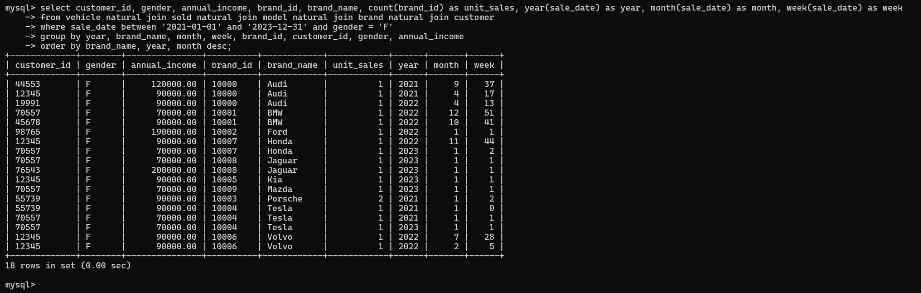

* + Income > 70,000

select customer_id, gender, annual_income, brand_id, brand_name, count(brand_id) as

unit_sales, year(sale_date) as year, month(sale_date) as month, week(sale_date) as week

from vehicle natural join sold natural join model natural join brand natural join customer

where sale_date between '2021-01-01' and '2023-12-31' and annual_income > 70000

group by year, brand_name, month, week, brand_id, customer_id, gender, annual_income

order by brand_name, year, month desc;

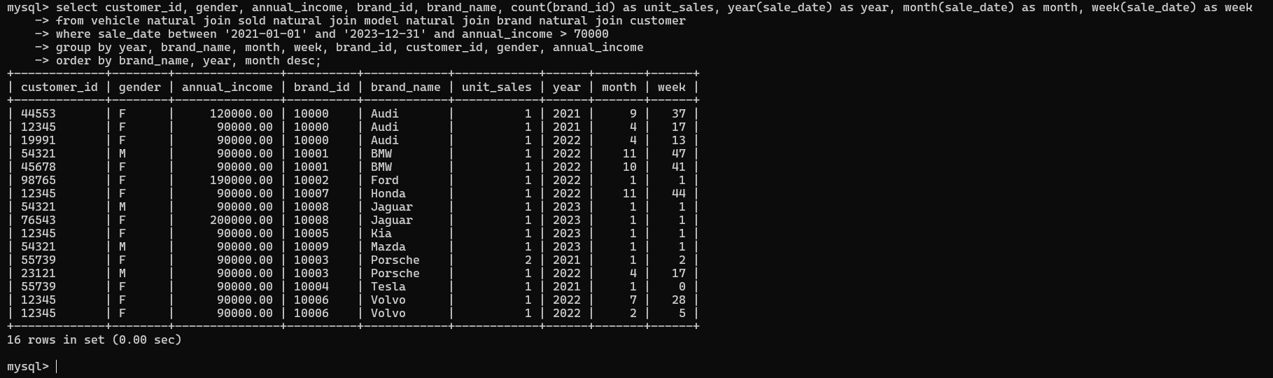

* + Income <= 70,000

select customer_id, gender, annual_income, brand_id, brand_name, count(brand_id) as

unit_sales, year(sale_date) as year, month(sale_date) as month, week(sale_date) as week

from vehicle natural join sold natural join model natural join brand natural join customer

where sale_date between '2021-01-01' and '2023-12-31' and annual_income <= 70000

group by year, brand_name, month, week, brand_id, customer_id, gender, annual_income

order by brand_name, year, month desc;

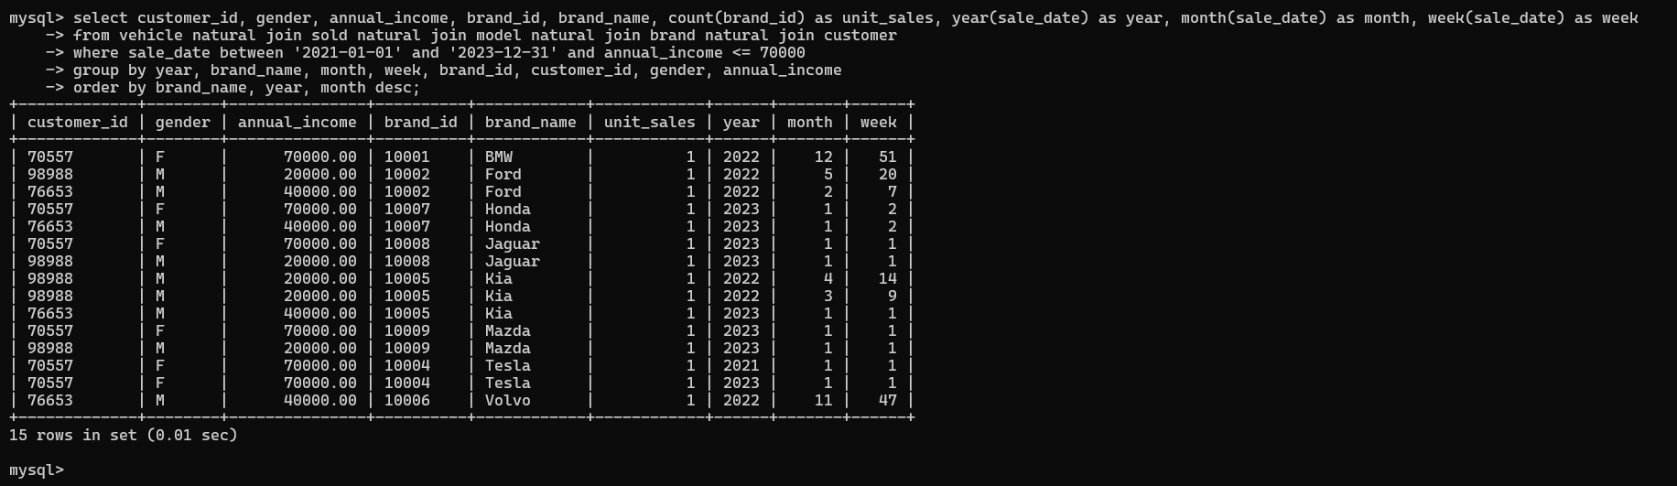

* Suppose that it is found that transmissions made by supplier Getrag between two given dates are defective. Find the VIN of each car containing such a transmission and the customer to which it was sold. If your design allows, suppose the defective transmissions all come from only one of Getrag’s plants.

create view vehicle_supplier_sold(VID, supplier_name, customer_id, sale_date) as

select VIN, supplier_name, customer_id, sale_date

from vehicle natural join model natural join supplier natural join sold;

select VID, supplier_name, customer_id, sale_date

from vehicle_supplier_sold

where supplier_name = 'Getrag' and sale_date between '2021-01-01' and '2022-12-30';

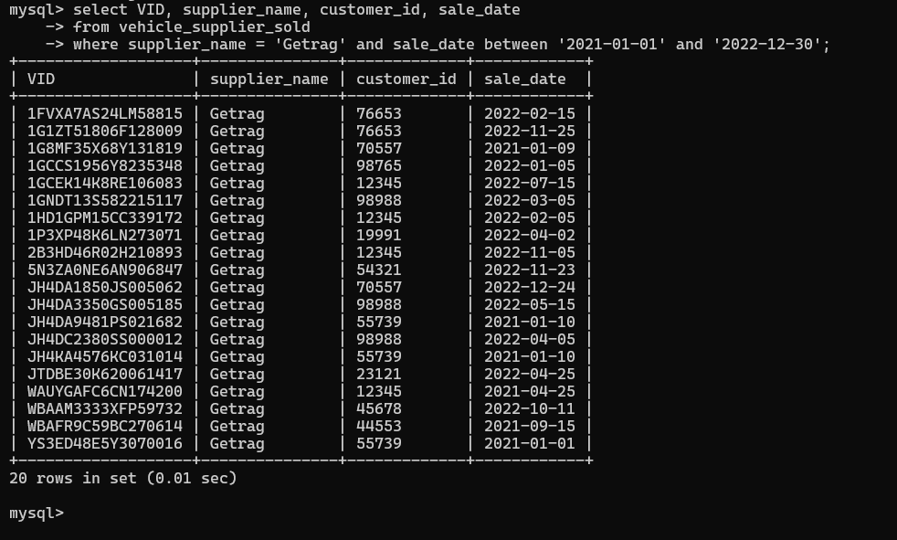

* + Same query but with more customer information:

select VID, supplier_name, customer_id, sale_date, customer_name, customer_address,

phone, gender, annual_income

from vehicle_supplier_sold natural join customer

where supplier_name = 'Getrag' and sale_date between '2021-01-01' and '2022-12-30';

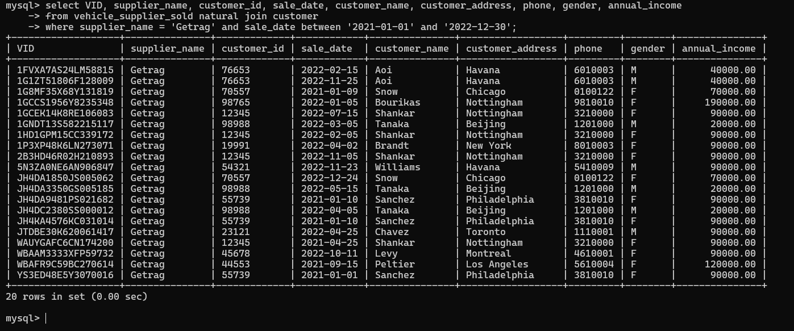

* Find the top 2 brands by dollar-amount sold in the past year.

with past_year_sold(brand_id, sale_date, price) as

(select brand_id, sale_date, price

from vehicle natural join model natural join sold

where year(sale_date) = 2022)

select brand_id, brand_name, sum(price) as dollar_amount

from past_year_sold natural join brand

group by brand_id

order by dollar_amount desc

limit 2;

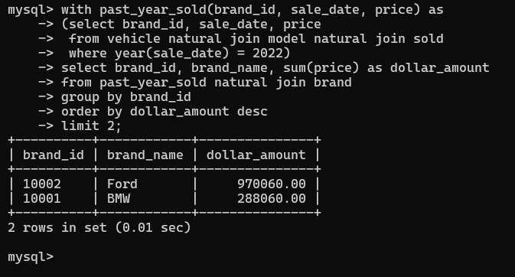

* + OLAP results for the query:

with past_year_sold(brand_id, past_year, dollar_amount) as

(select brand_id, year(sale_date) as past_year, sum(price) as dollar_amount

from vehicle natural join model natural join sold

where year(sale_date) = 2022

group by brand_id, year(sale_date))

select brand_id, brand_name, past_year, dollar_amount,

dense_rank() over (order by dollar_amount desc) ranking

from past_year_sold natural join brand;

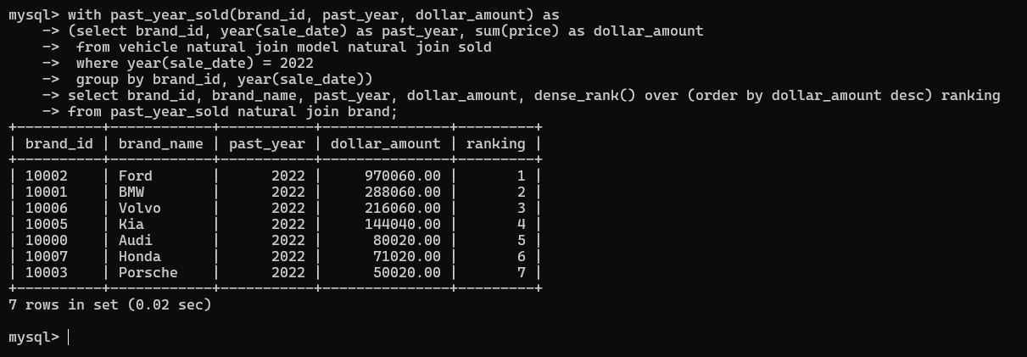

with past_year_sold(brand_id, past_year, dollar_amount) as

(select brand_id, year(sale_date) as past_year, sum(price) as dollar_amount

from vehicle natural join model natural join sold

where year(sale_date) = 2022

group by brand_id, year(sale_date))

select * from

(select brand_id, brand_name, past_year, dollar_amount,

dense_rank() over (order by dollar_amount desc) as ranking

from past_year_sold natural join brand)

as r

where r.ranking <= 2;

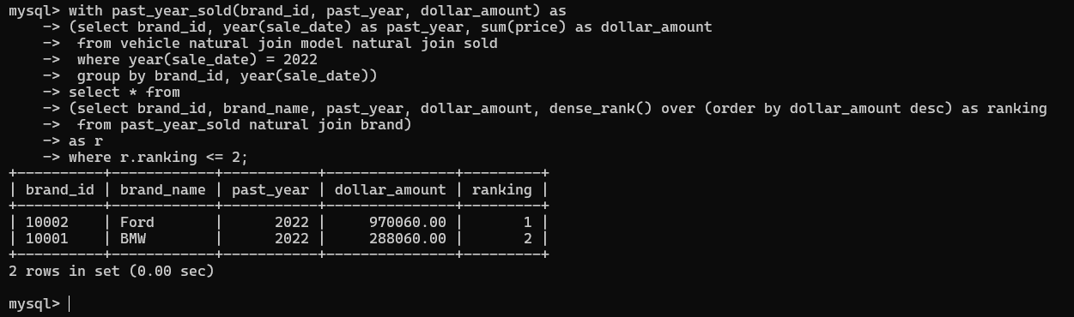

* Find the top 2 brands by unit sales in the past year.

with past_year_sold(brand_id, sale_date) as

(select brand_id, sale_date

from vehicle natural join model natural join sold

where year(sale_date) = 2022)

select brand_id, brand_name, count(sale_date) as unit_sales

from past_year_sold natural join brand

group by brand_id

order by unit_sales desc

limit 2;

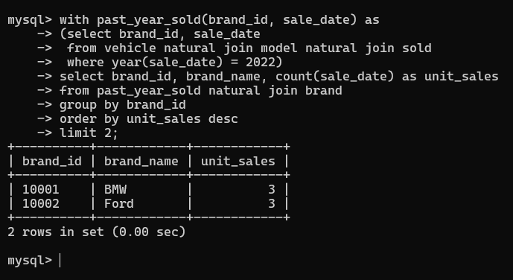

* + OLAP results for the query:

with past_year_sold(brand_id, past_year, unit_sales) as

(select brand_id, year(sale_date) as past_year, count(price) as unit_sales

from vehicle natural join model natural join sold

where year(sale_date) = 2022

group by brand_id, year(sale_date))

select * from

(select brand_id, brand_name, past_year, unit_sales,

dense_rank() over (order by unit_sales desc) as ranking

from past_year_sold natural join brand)

as r

where r.ranking <= 2;

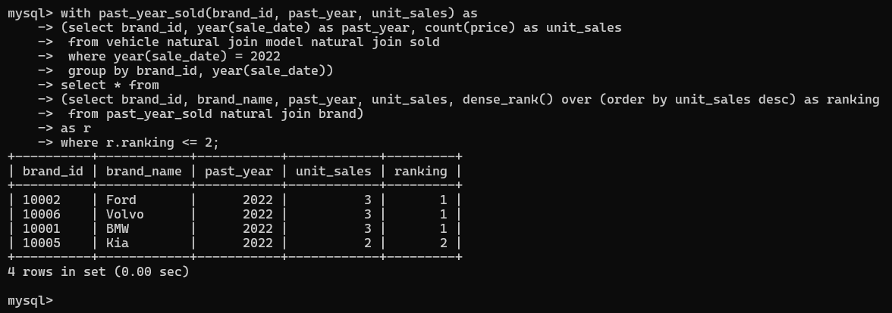

* In what month(s) do convertibles sell best?

select body_style, month(sale_date) as month, count(model_id) as sell_count

from vehicle natural join model natural join sold

where body_style = 'Convertible'

group by month

order by sell_count desc;

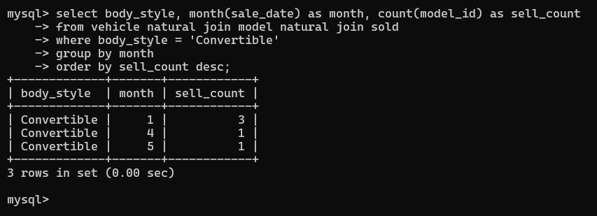

* Find those dealers who keep a vehicle in inventory for the longest average time.

select dealer_id, dealer_name, datediff(sale_date, stock_date) as inventory_time

from vehicle natural join sold natural join dealer

order by inventory_time desc;

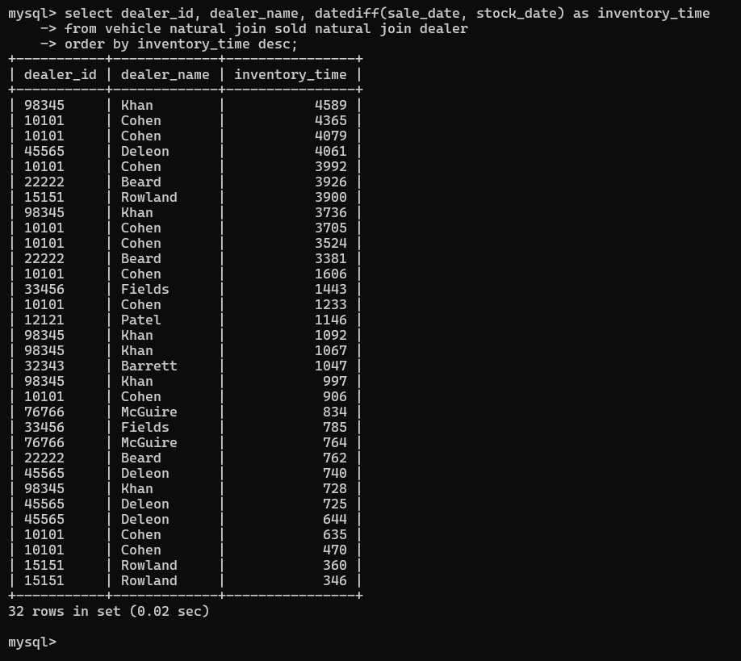

Conclusions:

From this project I have learned:

* How to create a database in MySQL using the SQL query language.
* How to populate the database with sufficient and interesting data.
* How to connect the database to an interface (CLI) and run proper queries to display information that is required.